Cohort 1, Team 4: Asmaa Abutaha, JP Camino, Surabhi Ghag, Emily Gomez, Nan Wang, Linghao Zhu

**Executive summary**

Hult Data Science: R

Cohort 1, Team 4: JP Camino, Nan Wang, Surabhi Ghag, Linghao Zhu, Asmaa Abutaha, and Emily Gomez

Team 4 analyzed Quality Alloy’s use of the promotion for the website and the added value from said promotion. Upon analysis, we have concluded that we cannot confidently say that the website adds value to support further promotion. We recommend collecting more data and reevaluating the company’s strategic plan after review. Below we explain what brought us to this conclusion, and we will go more in depth on what is recommended.

When assessing Quality Alloy’s website analytics data along with the financial data, several things stood out. Beginning with the website analytics, comparing website visit rates over time from before the promotion to after the promotion, there was a significant jump in number of visits during the time of the promotion. This is positive in that it can be concluded that the promotion was effective in bringing more web traffic to the website. However, when considering the bounce rate, time spent on a page, and the number of pages viewed, it brings concerns. During the promotional period, there are many more people visiting the website, especially for the first time. Unfortunately, these people are also viewing fewer pages, staying on viewed pages for less time, and leaving the website from the opening page at higher rates. This leads us to believe that people are not finding what they are looking for upon reaching the website. Given that the time is shorter, we cannot say that they are not finding the desired information, because it does not appear that they spend much time looking. What we believe is happening is that the promotion is attracting people who are not actually in the target market or interested in the product.

Regarding the financial data, if the promotion and website had been effective, then we would expect to see higher revenues related to higher visit rates. What we see is that from the introduction of the website through the pre-promotion, promotional, and post-promotion stages, there are decreases in revenue each period. We also see decreases in average profit from period to period. While decreased profit in the pre-promotional period would be reasonable due to promotion expenditures, it would be in the anticipation of higher profits during the promotional period. Since there is a steady decrease despite increased number of visitors, we further support that the promotion is targeting the wrong group of people.

External factors could also play a role in this analysis, but given the provided information, we cannot confidently say to what degree these factors affect the company. 2008 was the year that the world economy started to crash. Knowing this, it may be more reasonable to see decreases in revenue and profit. Ideally to know how effective the website is, we would want to know how the company would have done in the same economic environment without the website. While that information is not available for Quality Alloys, we suggest collecting performance data from other competitors in the market. If every company performed about the same, then the website did not lend extra benefit. If other companies seemed to fare much worse, the website may have been what kept QA from decreasing profits further.

Another piece of information that would be more helpful in analysis is product sales information. The pounds sold of various products could be affected by the economic wealth available. While lbs. sold increased in 2010, revenues on average were still down. The type of product sold could be a contributing factor.

Altogether, we conclude that more information is needed before investing more into the website and promotion. Until the website is improved, we recommend not promoting further. The information that would be more beneficial in further analysis would be:

* Information on the target market- buying preferences, purchase behavior, desired information (for the improvement of the website), level of expertise (do they always need to speak to an employee before buying), etc.
* Information on the competitors in the market for the given time period (to assess true impact of the website during an economic shift)
* Source of previous purchasers (online, print ads, word-of mouth, etc.)

For now, we recommend not promoting further, collecting more data, but keeping the website. We believe that the general direction of commerce is towards e-commerce and digital marketing. The website could be highly beneficial in proving information to clients. The current advertisements should be reevaluated to be more targeted, especially with placement and key words, because they are reaching undesired people. The future goal is to improve the website to add value to the company and keep up with market changes. Potential decisions, once more information is analyzed, may include the use of IVR (interactive virtual response) such as chat boxes, the possibility of creating quick, online quotes, FAQ pages, or a newsletter signup option for new products.

If you would like the numbers and figures behind our analysis or have any follow-up questions, please contact us via the information below.

Cohort 1, Team 4

[Egomez2019@student.hult.edu](mailto:Egomez2019@student.hult.edu)

[Jcaminomolina2019@student.hult.edu](mailto:Jcaminomolina2019@student.hult.edu)

**Analysis:**

library(readxl)

library(ggplot2)

Web_Analytics_Weekly_Visits <- read_excel("Web Analytics Case Student Spreadsheet.xls",

sheet = "Weekly Visits", range = "A5:H71"

)

Web_Analytics_Financials <- read_excel("Web Analytics Case Student Spreadsheet.xls",

sheet = "Financials", range = "A5:E71"

)

Web_Analytics_Lbs_Sold <- read_excel("Web Analytics Case Student Spreadsheet.xls",

sheet = "Lbs. Sold", range = "A5:B295"

)

**1)**

head(Web_Analytics_Weekly_Visits)

Web_Analytics_Weekly_Visits$`Week (2008-2009)` <- factor(Web_Analytics_Weekly_Visits$`Week (2008-2009)`, levels = Web_Analytics_Weekly_Visits$`Week (2008-2009)`)

Web_Analytics_Financials$`Week (2008-2009)` <- factor(Web_Analytics_Financials$`Week (2008-2009)`, levels = Web_Analytics_Financials$`Week (2008-2009)`)

q1_plot_bar_visits <- ggplot(data = Web_Analytics_Weekly_Visits, aes(x = Web_Analytics_Weekly_Visits$`Week (2008-2009)`, y = Web_Analytics_Weekly_Visits$Visits)) +

geom_bar(stat = "identity", fill = "steelblue") + theme(axis.text.x = element_text(angle = 90, colour = "black")) +

labs(x = "", y = "") + ggtitle("FIGURE 1. VISITS TO THE QA WEBSITE PER WEEK. ")

q1_plot_bar_visits

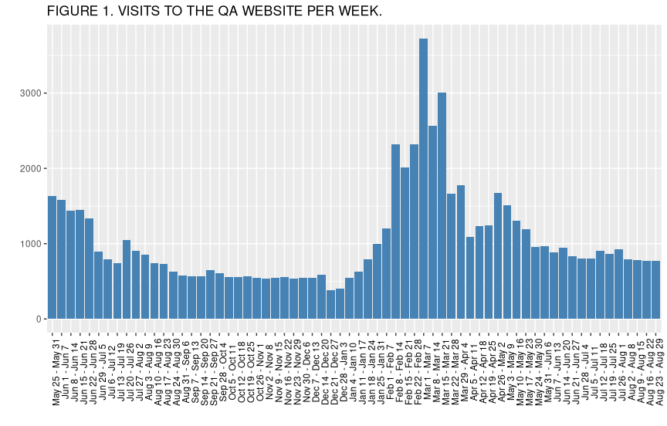

q1_plot_bar_uniqu_visits <- ggplot(data = Web_Analytics_Weekly_Visits, aes(x = Web_Analytics_Weekly_Visits$`Week (2008-2009)`, y = Web_Analytics_Weekly_Visits$`Unique Visits`)) +

geom_bar(stat = "identity", fill = "steelblue") + theme(axis.text.x = element_text(angle = 90, colour = "black")) +

labs(x = "", y = "") + ggtitle("FIGURE 2. UNIQU VISITS TO THE QA WEBSITE PER WEEK. ")

q1_plot_bar_uniqu_visits

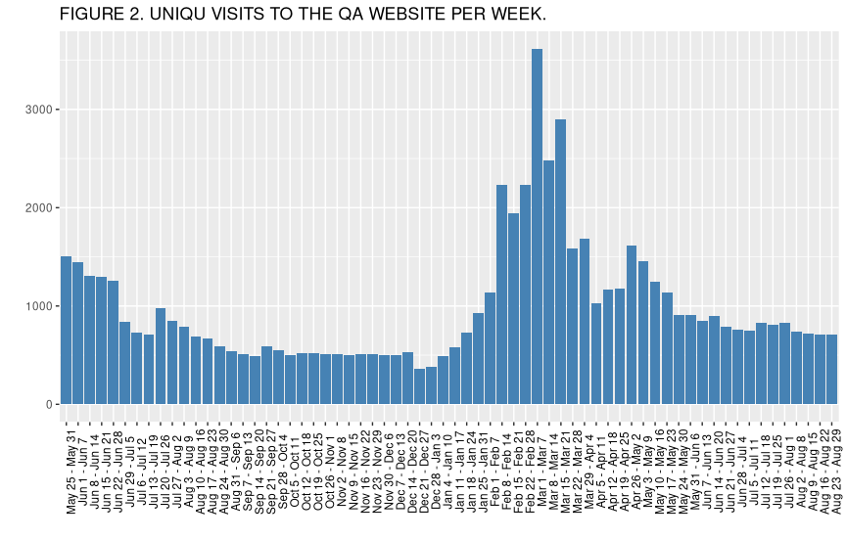

q1_plot_bar_revenue <- ggplot(data = Web_Analytics_Financials, aes(x = Web_Analytics_Financials$`Week (2008-2009)`, y = Web_Analytics_Financials$Revenue)) +

geom_bar(stat = "identity", fill = "steelblue") + theme(axis.text.x = element_text(angle = 90, colour = "black")) +

labs(x = "", y = "") + ggtitle("FIGURE 3. QA REVENUE PER WEEK. ")

q1_plot_bar_revenue

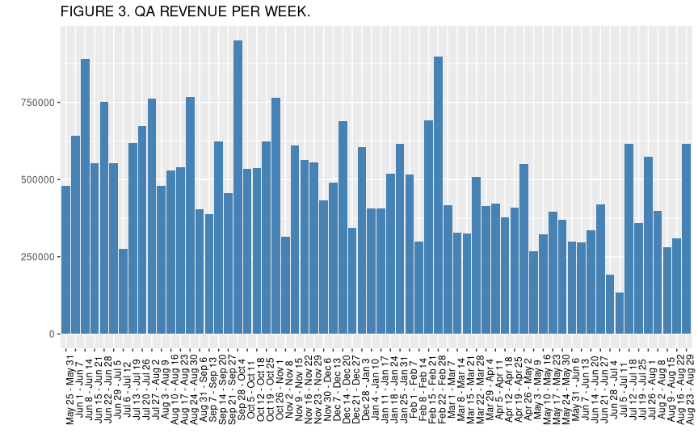

q1_plot_bar_profit <- ggplot(data = Web_Analytics_Financials, aes(x = Web_Analytics_Financials$`Week (2008-2009)`, y = Web_Analytics_Financials$Profit)) +

geom_bar(stat = "identity", fill = "steelblue") + theme(axis.text.x = element_text(angle = 90, colour = "black")) +

labs(x = "", y = "") + ggtitle("FIGURE 4. QA PROFIT PER WEEK. ")

q1_plot_bar_profit

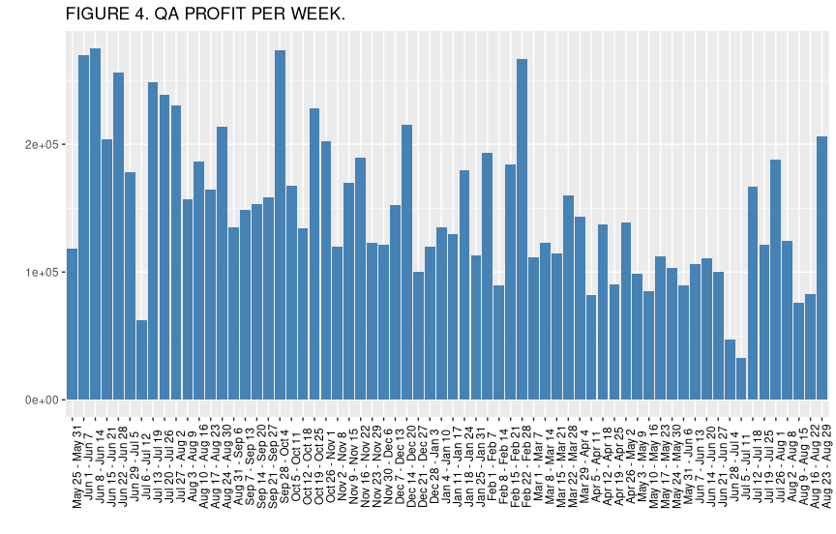

q1_plot_bar_pounds_sold <- ggplot(data = Web_Analytics_Financials, aes(x = Web_Analytics_Financials$`Week (2008-2009)`, y = Web_Analytics_Financials$`Lbs. Sold`)) +

geom_bar(stat = "identity", fill = "steelblue") + theme(axis.text.x = element_text(angle = 90, colour = "black")) +

labs(x = "", y = "") + ggtitle("FIGURE 5. QA POUNDS SOLD PER WEEK. ")

q1_plot_bar_pounds_sold

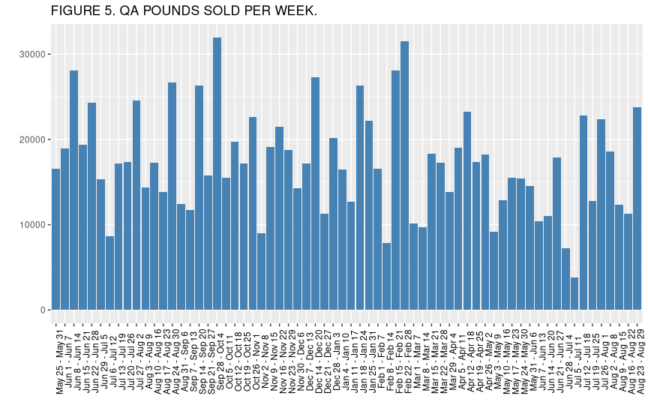

**2)**

s_a_data <- function(my_data, period_code = 0) {

if (period_code == 1) {

my_data <- my_data[1:14]

} else if (period_code == 2) {

my_data <- my_data[15:35]

} else if (period_code == 3) {

my_data <- my_data[36:52]

} else if (period_code == 4) {

my_data <- my_data[53:66]

} else {

my_data <- my_data

}

return(c(mean(my_data), median(my_data), sd(my_data), min(my_data), max(my_data)))

}

table_1 <- as.data.frame(matrix(nrow = 5, ncol = 0))

table_1$Visits <- s_a_data(Web_Analytics_Weekly_Visits$Visits, 1)

table_1$`Unique Visits` <- s_a_data(Web_Analytics_Weekly_Visits$`Unique Visits`, 1)

table_1$Revenue <- s_a_data(Web_Analytics_Financials$Revenue, 1)

table_1$Profit <- s_a_data(Web_Analytics_Financials$Profit, 1)

table_1$`Lbs. Sold` <- s_a_data(Web_Analytics_Financials$`Lbs. Sold`, 1)

table_2 <- as.data.frame(matrix(nrow = 5, ncol = 0))

table_2$Visits <- s_a_data(Web_Analytics_Weekly_Visits$Visits, 2)

table_2$`Unique Visits` <- s_a_data(Web_Analytics_Weekly_Visits$`Unique Visits`, 2)

table_2$Revenue <- s_a_data(Web_Analytics_Financials$Revenue, 2)

table_2$Profit <- s_a_data(Web_Analytics_Financials$Profit, 2)

table_2$`Lbs. Sold` <- s_a_data(Web_Analytics_Financials$`Lbs. Sold`, 2)

table_3 <- as.data.frame(matrix(nrow = 5, ncol = 0))

table_3$Visits <- s_a_data(Web_Analytics_Weekly_Visits$Visits, 3)

table_3$`Unique Visits` <- s_a_data(Web_Analytics_Weekly_Visits$`Unique Visits`, 3)

table_3$Revenue <- s_a_data(Web_Analytics_Financials$Revenue, 3)

table_3$Profit <- s_a_data(Web_Analytics_Financials$Profit, 3)

table_3$`Lbs. Sold` <- s_a_data(Web_Analytics_Financials$`Lbs. Sold`, 3)

table_4 <- as.data.frame(matrix(nrow = 5, ncol = 0))

table_4$Visits <- s_a_data(Web_Analytics_Weekly_Visits$Visits, 4)

table_4$`Unique Visits` <- s_a_data(Web_Analytics_Weekly_Visits$`Unique Visits`, 4)

table_4$Revenue <- s_a_data(Web_Analytics_Financials$Revenue, 4)

table_4$Profit <- s_a_data(Web_Analytics_Financials$Profit, 4)

table_4$`Lbs. Sold` <- s_a_data(Web_Analytics_Financials$`Lbs. Sold`, 4)

row.names(table_1) <- c("mean", "median", "standard deviation", "minimum", "maximum")

row.names(table_2) <- c("mean", "median", "standard deviation", "minimum", "maximum")

row.names(table_3) <- c("mean", "median", "standard deviation", "minimum", "maximum")

row.names(table_4) <- c("mean", "median", "standard deviation", "minimum", "maximum")

Table_1

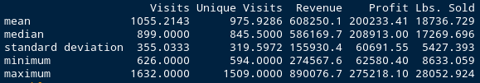

table_2

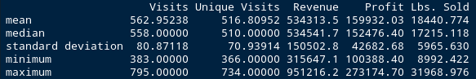

table_3

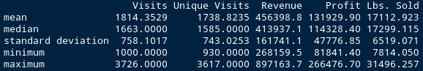

table_4

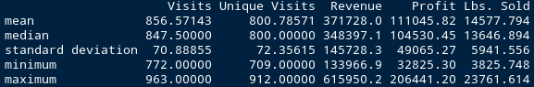

**3)**

means_df <- function(my_data) {

return(c(mean(my_data[1:14]), mean(my_data[15:35]), mean(my_data[36:52]), mean(my_data[53:66])))

}

q3_table <- as.data.frame(matrix(nrow = 4, ncol = 0))

q3_table$Visits <- means_df(Web_Analytics_Weekly_Visits$Visits)

q3_table$`Unique Visits` <- means_df(Web_Analytics_Weekly_Visits$`Unique Visits`)

q3_table$Revenue <- means_df(Web_Analytics_Financials$Revenue)

q3_table$Profit <- means_df(Web_Analytics_Financials$Profit)

q3_table$`Lbs. Sold` <- means_df(Web_Analytics_Financials$`Lbs. Sold`)

q3_table$period <- c("initial", "pre-promotion", "promotion", "post-promotion")

q3_table

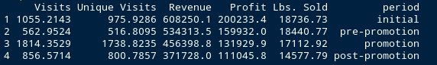

q3_table$period <- factor(q3_table$period, levels = c("initial", "pre-promotion", "promotion", "post-promotion"))

q3_box <- ggplot(data = q3_table, aes(x = q3_table$period, y = q3_table$Visits)) +

geom_bar(stat = "identity", fill = "steelblue") + theme(axis.text.x = element_text(angle = 90, colour = "black")) +

labs(x = "", y = "") + ggtitle(" ")

q3_box

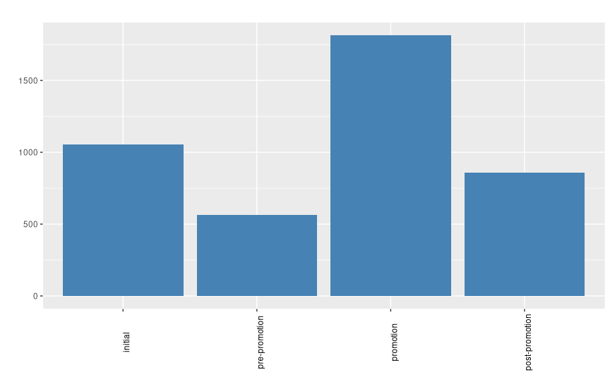

q3_box_revenue <- ggplot(data = q3_table, aes(x = q3_table$period, y = q3_table$Revenue)) +

geom_bar(stat = "identity", fill = "steelblue") + theme(axis.text.x = element_text(angle = 90, colour = "black")) +

labs(x = "", y = "") + ggtitle("means of revenue in four periods")

q3_box_revenue

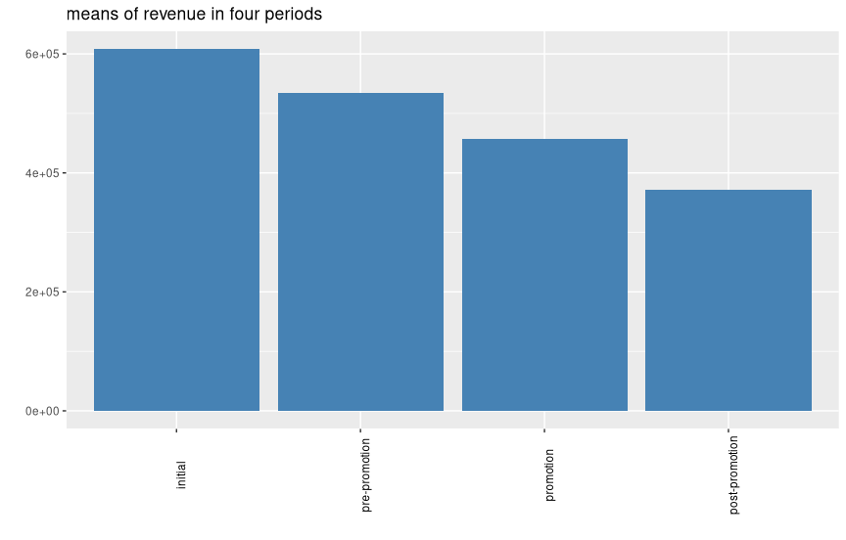

q3_box_profit <- ggplot(data = q3_table, aes(x = q3_table$period, y = q3_table$Profit)) +

geom_bar(stat = "identity", fill = "steelblue") + theme(axis.text.x = element_text(angle = 90, colour = "black")) +

labs(x = "", y = "") + ggtitle("means of profit in four periods")

q3_box_profit

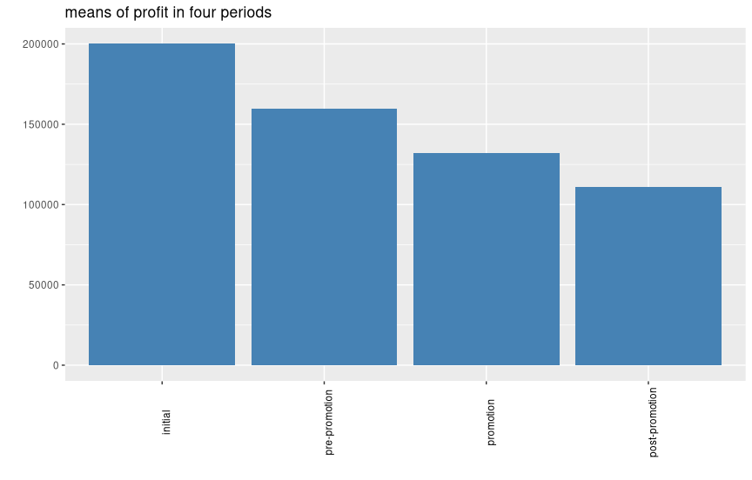

q3_box_lbs_sold <- ggplot(data = q3_table, aes(x = q3_table$period, y = q3_table$`Lbs. Sold`)) +

geom_bar(stat = "identity", fill = "steelblue") + theme(axis.text.x = element_text(angle = 90, colour = "black")) +

labs(x = "", y = "") + ggtitle("means of lbs. sold in four periods")

q3_box_lbs_sold

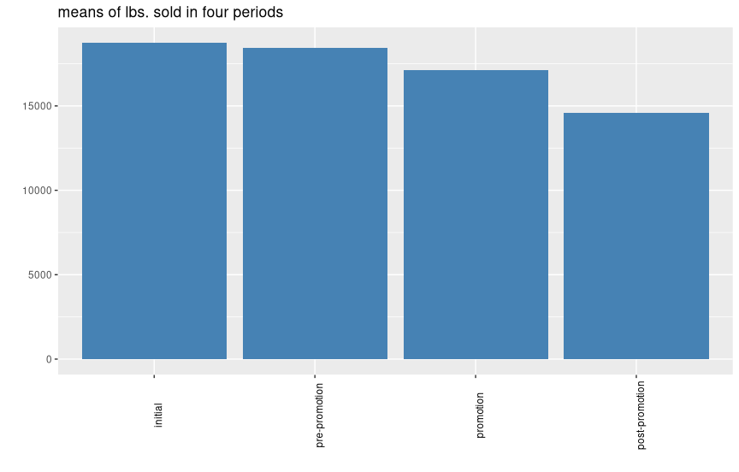

**4)**

The initial period: May 25, 2008 to August 30, 2008

The Pre-Promotion period: August 31, 2008 to January 24, 2009

The Promotion period: January 25, 2009 to May 23, 2009

The Post-Promotion: May 24, 2009 to August 22, 2009

Quality Alloy’s visits and unique visits increase significantly during the promotional period. Before and after the promotional period visits are much lower. In fact, pre-promotion saw the lowest average weekly visits. This means that the new visitors brought by the promotion are not maintained. Based on the nature of the business and unique orders along with not having a shopping cart feature, it may be acceptable to have a high number of unique visits. While the average promotional number of visits was the highest, it also had the largest range, variance, and standard deviation. The average revenue and profits decrease over each time period. The pounds of product sold increases during 2008 but then decreases in 2009 before increasing again. Overall pounds of product sold decreases from period to period. Because we see visits increase but revenue and profits decrease, we conclude that an increase in visits does not necessarily mean an increase in revenue and profits. Interestingly, one would think an increase in lbs. of product sold would indicate an increase in revenue. However, this is not observed to the expected degree. This may be due to product sales variation.

While the promotion brought more visitors to the website, the website is not effective in increasing revenue. This could be due to attracting consumers who aren’t interested in the company and its products or through lack of useful and desired information that would drive sales. profits per week follow a downward trend with some variation.

**5)** Scatter plot of the revenue versus pounds sold show direct proportion between the revenue and pounds sold. An increase in pounds sold correlates with an increase in revenue. Since revenue increases with an increase in pounds sold, it follows that profits would be expected to increase with pounds sold as seen in the data. The correlation coefficient is 0.8689.

q5_df <- as.data.frame(matrix(nrow = nrow(Web_Analytics_Financials), ncol = 0))

q5_df$Revenue <- Web_Analytics_Financials$Revenue

q5_df$`Lbs. Sold` <- Web_Analytics_Financials$`Lbs. Sold`

q5_cor <- cor(q5_df)

q5_cor



q5_sca <- ggplot(q5_df, aes(x = q5_df$`Lbs. Sold`, y = q5_df$Revenue)) + geom_point() + geom_smooth(method = lm) + theme(axis.text.x = element_text(colour = "black")) +

labs(x = "Lbs. Sold", y = "Revenue") + ggtitle("scatter diagram of revenue versus pounds sold")

q5_sca

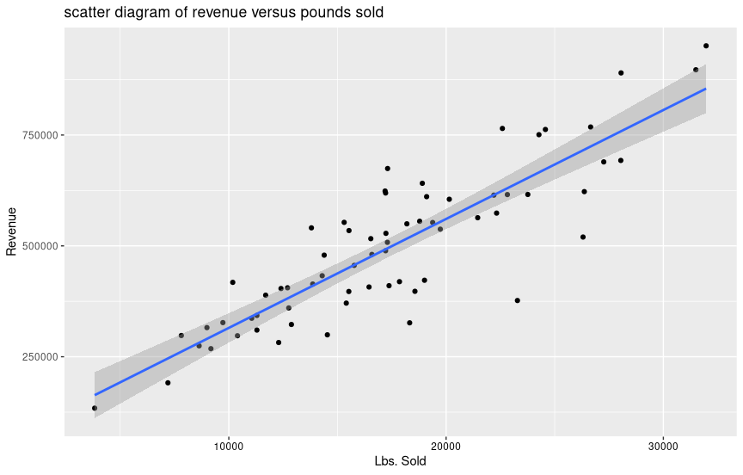

**6)** The correlation coefficient is -0.0594.

q6_df <- as.data.frame(matrix(nrow = nrow(Web_Analytics_Financials), ncol = 0))

q6_df$Revenue <- Web_Analytics_Financials$Revenue

q6_df$Visits <- Web_Analytics_Weekly_Visits$Visits

q6_cor <- cor(q6_cor)

q6_cor



q6_sca <- ggplot(q6_df, aes(x = q6_df$Visits, y = q6_df$Revenue)) + geom_point() + geom_smooth(method = lm) + theme(axis.text.x = element_text(colour = "black")) +

labs(x = "Visits", y = "Revenue") + ggtitle("scatter diagram of revenue versus visits")

q6_sca

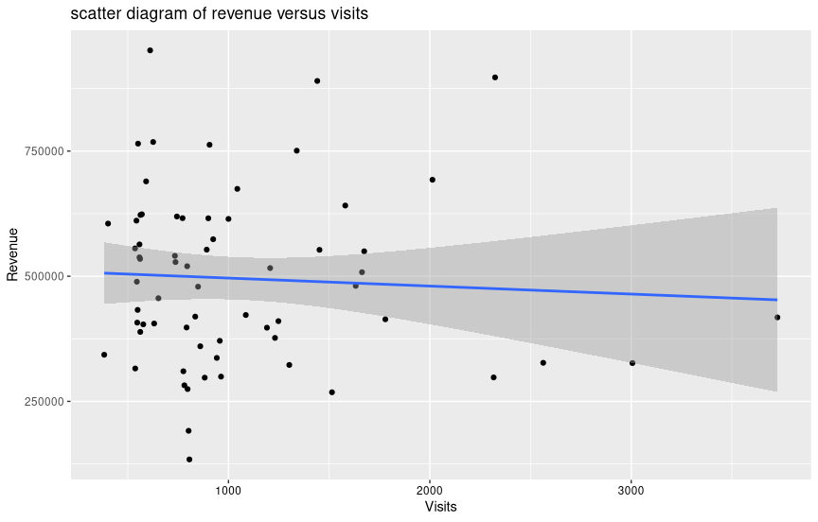

**7)** The scatter plot of the revenue and visits shows no direct correlation. Since the promotion brought more people to the website, if the website was effective, we would expect to see an increase in revenue. Since revenue decreases even as the number of visits increases, it is concluded that the website is not effective.

**8)**

**a)**

q8_a_summary_value <- as.data.frame(matrix())

q8_a_summary_value <- s_a_data(Web_Analytics_Lbs_Sold$`Lbs. Sold`)

names(q8_a_summary_value) <- c("mean", "median", "standard deviation", "minimum", "maximum")

q8_a_summary_value



**b)**

q8_b_hist <- ggplot(data=Web_Analytics_Lbs_Sold, aes(Web_Analytics_Lbs_Sold$`Lbs. Sold`)) +

geom_histogram(fill = "steelblue") + theme(axis.text.x = element_text(angle = 90, colour = "black")) +

labs(x = "Lbs. Sold", y = "Count") + ggtitle("Lbs. Sold Histogram")

q8_b_hist

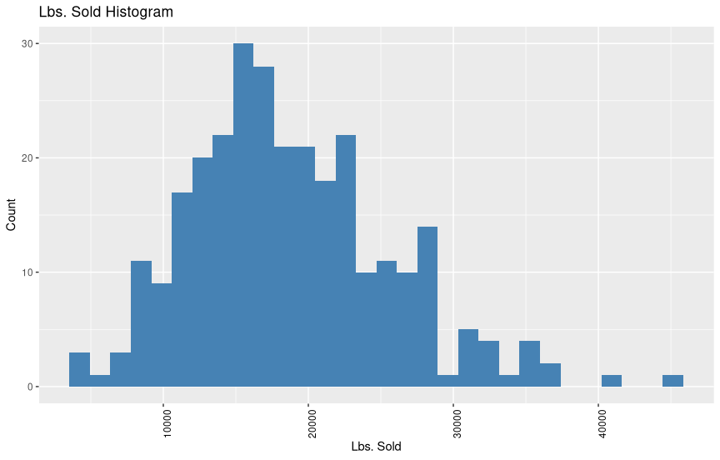

**c)** The histogram does appear bell-shaped with a few outliers. The mean is higher than the median, most likely due to these outliers pulling the mean slightly to the right.

**d)**

q8_z_score_func <- function(vector_1, m, sd) {

z_score_list <- c()

for (i in nrow(vector_1)) {

z_score_list[i] <- (vector_1[i] - m) / sd

}

return(z_score_list)

}

q8_d_table <- as.data.frame(matrix(nrow = 3, ncol = 0))

q8_d_table$Interval <- c("mean ± 1 std. dev.", "mean ± 2 std. dev.", "mean ± 3 std. dev.")

q8_d_table$`Theoretical % of Data` <- c("68%", "95%", "99%")

q8_d_table$`Theoretical No. Obs.` <- c(0.68, 0.95, 0.99) * nrow(Web_Analytics_Lbs_Sold)

q8_d_table$`Actual No. Obs.` <- c(0, 0, 0)

Web_Analytics_Lbs_Sold$`z-score` <- (Web_Analytics_Lbs_Sold$`Lbs. Sold` - mean(Web_Analytics_Lbs_Sold$`Lbs. Sold`)) / sd(Web_Analytics_Lbs_Sold$`Lbs. Sold`)

Web_Analytics_Lbs_Sold

q8_Web_Analytics_Lbs_Sold <- Web_Analytics_Lbs_Sold[order(Web_Analytics_Lbs_Sold$`z-score`), ]

q8_Web_Analytics_Lbs_Sold

for (i in 1:nrow(q8_Web_Analytics_Lbs_Sold)) {

if (q8_Web_Analytics_Lbs_Sold$`z-score`[i] <= 1 & q8_Web_Analytics_Lbs_Sold$`z-score`[i] >= -1) {

q8_d_table$`Actual No. Obs.`[1] <- q8_d_table$`Actual No. Obs.`[1] + 1

}

if (q8_Web_Analytics_Lbs_Sold$`z-score`[i] <= 2 & q8_Web_Analytics_Lbs_Sold$`z-score`[i] >= -2) {

q8_d_table$`Actual No. Obs.`[2] <- q8_d_table$`Actual No. Obs.`[2] + 1

}

if (q8_Web_Analytics_Lbs_Sold$`z-score`[i] <= 3 & q8_Web_Analytics_Lbs_Sold$`z-score`[i] >= -3) {

q8_d_table$`Actual No. Obs.`[3] <- q8_d_table$`Actual No. Obs.`[3] + 1

}

}

q8_d_table

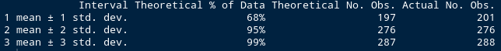

**e)**

q8_e_table <- as.data.frame(matrix(nrow = 6, ncol = 0))

q8_e_table$Interval <- c("mean + 1 std. dev.", "mean - 1 std. dev.", "1 std. dev. to 2 std. dev.", "-1 std. dev. to -2 std. dev.", "2 std. dev. to 3 std. dev.", "-2 std. dev. to -3 std. dev.")

q8_e_table$`Theoretical % of Data` <- c("34%", "34%", "13.5%", "13.5%", "2%", "2%")

q8_e_table$`Theoretical No. Obs.` <- c(0.34, 0.34, 0.135, 0.135, 0.02, 0.02) * nrow(Web_Analytics_Lbs_Sold)

q8_e_table$`Actual No. Obs.` <- c(0, 0, 0, 0, 0, 0)

for (i in 1:nrow(q8_Web_Analytics_Lbs_Sold)) {

if (q8_Web_Analytics_Lbs_Sold$`z-score`[i] <= 1 & q8_Web_Analytics_Lbs_Sold$`z-score`[i] >= 0) {

q8_e_table$`Actual No. Obs.`[1] <- q8_e_table$`Actual No. Obs.`[1] + 1

}

if (q8_Web_Analytics_Lbs_Sold$`z-score`[i] <= 0 & q8_Web_Analytics_Lbs_Sold$`z-score`[i] >= -1) {

q8_e_table$`Actual No. Obs.`[2] <- q8_e_table$`Actual No. Obs.`[2] + 1

}

if (q8_Web_Analytics_Lbs_Sold$`z-score`[i] <= 2 & q8_Web_Analytics_Lbs_Sold$`z-score`[i] >= 1) {

q8_e_table$`Actual No. Obs.`[3] <- q8_e_table$`Actual No. Obs.`[3] + 1

}

if (q8_Web_Analytics_Lbs_Sold$`z-score`[i] <= -1 & q8_Web_Analytics_Lbs_Sold$`z-score`[i] >= -2) {

q8_e_table$`Actual No. Obs.`[4] <- q8_e_table$`Actual No. Obs.`[4] + 1

}

if (q8_Web_Analytics_Lbs_Sold$`z-score`[i] <= 3 & q8_Web_Analytics_Lbs_Sold$`z-score`[i] >= 2) {

q8_e_table$`Actual No. Obs.`[5] <- q8_e_table$`Actual No. Obs.`[5] + 1

}

if (q8_Web_Analytics_Lbs_Sold$`z-score`[i] <= -2 & q8_Web_Analytics_Lbs_Sold$`z-score`[i] >= -3) {

q8_e_table$`Actual No. Obs.`[6] <- q8_e_table$`Actual No. Obs.`[6] + 1

}

}

q8_e_table

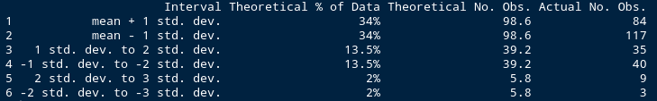

**f)** The data for pounds of material sold is similar to a normal distribution. However, it has more values concentrated on the left side of the distribution than the right. This along with the values further spread to the right supports why the median is less than the mean.

**g)**

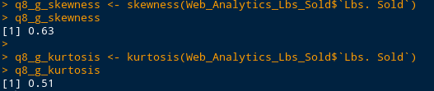

9) Daily visits is much more skewed to the right pulling the mean higher than the median. The tail for daily visits is stretched out over most of the histogram. The lbs. sold has what appears to be a few further out values to the right but they are not as concentrated or as far out to the right. It is also more concentrated within the first standard deviation. Lbs. sold’s actual values are overall closer to the theoretical values, especially in the first standard deviation.

10)

* The main two traffic sources are referring sites and search engines.

* The top referring sites are google ads (company investment) and sedoparking.

* Google is by far the highest source of visits from search engines. This makes sense since the ads are google ads. Does google analytics play a part in this data?

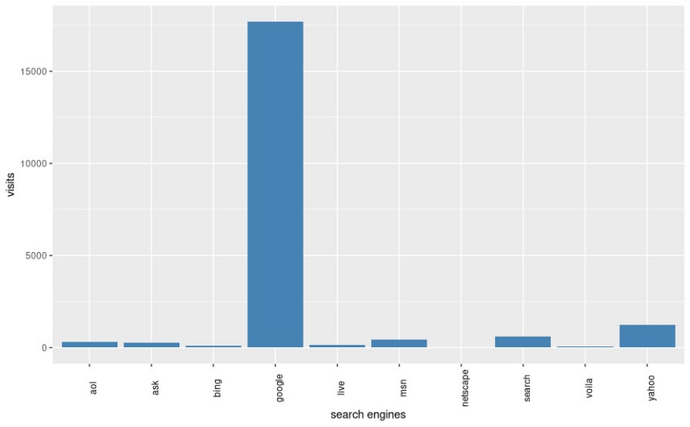

* The main visitors are from North and South America. Quality Alloys is interested in the Pacific Rim but Asia is not even close to the number of people from the Americas that visit the website. Maybe other methods should be pursued to reach that market.

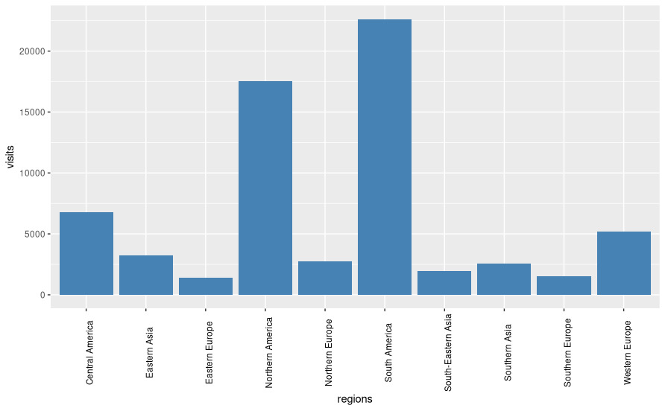

* Internet Explorer and Firefox are the main browsers useful.

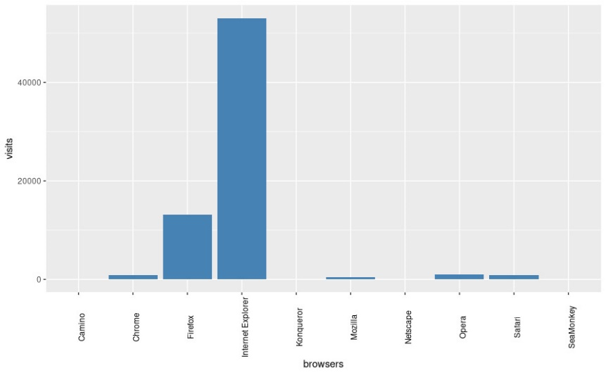

* Windows users are by far the most significant in visitors.

sources <- read_excel("Web Analytics Case Student Spreadsheet.xls", sheet = "Demographics", range = "B7:C11")

names(sources) <- c('sources','visits')

sites <- read_excel("Web Analytics Case Student Spreadsheet.xls", sheet = "Demographics", range = "B14:C24")

names(sites) <- c('sites','visits')

se <- read_excel("Web Analytics Case Student Spreadsheet.xls", sheet = "Demographics", range = "B27:C37")

names(se) <- c('search engines','visits')

regions <- read_excel("Web Analytics Case Student Spreadsheet.xls", sheet = "Demographics", range = "B40:C50")

names(regions) <- c('regions','visits')

browsers <- read_excel("Web Analytics Case Student Spreadsheet.xls", sheet = "Demographics", range = "B54:C64")

names(browsers) <- c('browsers','visits')

os <- read_excel("Web Analytics Case Student Spreadsheet.xls", sheet = "Demographics", range = "B68:C78")

names(os) <- c('operating systems','visits')

ggplot(sources) +

geom_bar(aes(x=sources,y=visits), fill = "steelblue",stat = "identity")

ggplot(sites) +

geom_bar(aes(x=sites,y=visits), fill = "steelblue",stat = "identity")

ggplot(se) +

geom_bar(aes(x=`search engines`,y=visits), fill = "steelblue",stat = "identity")

ggplot(regions) +

geom_bar(aes(x=regions,y=visits), fill = "steelblue",stat = "identity")

ggplot(browsers) +

geom_bar(aes(x=browsers,y=visits), fill = "steelblue",stat = "identity")

ggplot(os) +

geom_bar(aes(x=`operating systems`,y=visits), fill = "steelblue",stat = "identity")

ggplot(sources) +

geom_bar(aes(x=sources,y=visits), fill = "steelblue",stat = "identity")

ggplot(sites) +

geom_bar(aes(x=sites,y=visits), fill = "steelblue",stat = "identity")+ theme(axis.text.x = element_text(angle = 90, colour = "black"))

ggplot(se) +

geom_bar(aes(x=`search engines`,y=visits), fill = "steelblue",stat = "identity")+theme(axis.text.x = element_text(angle = 90, colour = "black"))

ggplot(regions) +

geom_bar(aes(x=regions,y=visits), fill = "steelblue",stat = "identity")+theme(axis.text.x = element_text(angle = 90, colour = "black"))

ggplot(browsers) +

geom_bar(aes(x=browsers,y=visits), fill = "steelblue",stat = "identity")+theme(axis.text.x = element_text(angle = 90, colour = "black"))

ggplot(os) +

geom_bar(aes(x=`operating systems`,y=visits), fill = "steelblue",stat = "identity")+theme(axis.text.x = element_text(angle = 90, colour = "black"))

**Extras / 10**

#bounce vs visits

numbers = c(1055.21, 562.95, 1814.35, 856.57,710 , 334, 1402, 568)

type = c('visits','visits','visits','visits','bounce','bounce','bounce','bounce')

bounce_rate = c(67.279, 59.414, 77.275, 66.331)

bounce_total = visits_period * bounce_rate /100

periods = c('initial','pre-promotion','promotion','post-promotion','initial','pre-promotion','promotion','post-promotion')

levels_p <- c('initial','pre-promotion','promotion','post-promotion')

visit_x_bounce_df = data.frame(periods,numbers,type)

ggplot(visit_x_bounce_df, aes(factor(periods,levels = levels_p),fill = type,y=numbers)) +

geom_bar(position=position_dodge(), stat="identity") +

scale_fill_manual(values=c('#e0c39b','#99b88d')) + labs(x = "Periods", y = "Total") + ggtitle("Total Visits vs Bounce")

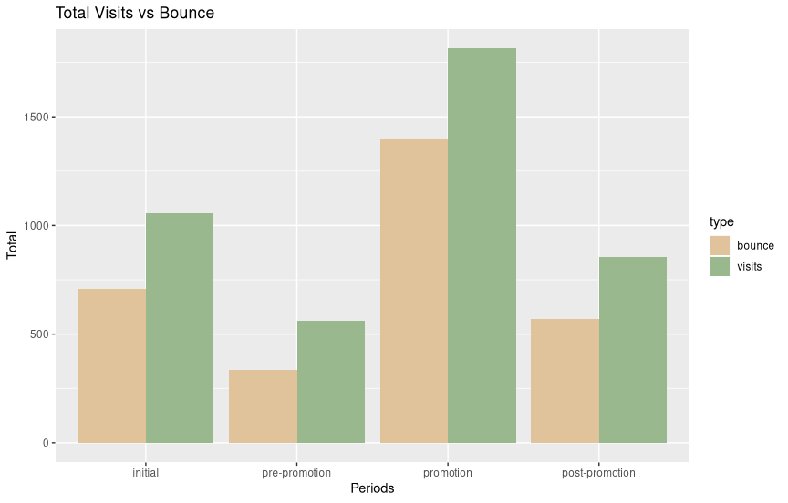

#average LBS. Sold per year

qa_lbs_sold_df$year <- c()

for (i in 1:nrow(qa_lbs_sold_df)) {

qa_lbs_sold_df$year[i] <- substr(as.character(qa_lbs_sold_df$Week[i]), 1, 4)

}

ggplot(qa_lbs_sold_df) +

geom_bar(aes(x=year,y=`Lbs. Sold`,), fill = "steelblue",stat = "summary", fun.y = "mean")

